|  |
| --- |
|  |
| Arcade Game Final |
| **Documentation** |
| Version 1  All work Copyright © 2012 by XX Games.  All rights reserved. |
| **By: Syeda Mehreen , Rukshar Patel** |
|  |



|  |
| --- |
| April 17th 2015 |

Table of Contents

Version History 3

Game Overview 4

Game Play Mechanics 4

Controls 4

Saving and Loading 4

Interface Sketch 4

Menu and Screen Descriptions 5

Game World 5

Game Progression 6

Characters 6

Enemies 6

Scripts 6

Scoring 6

Cheat Codes 6

Design Notes 7

Future Features 7

Sound Index 7

Art / Multimedia Index 7

References 10

# Version History

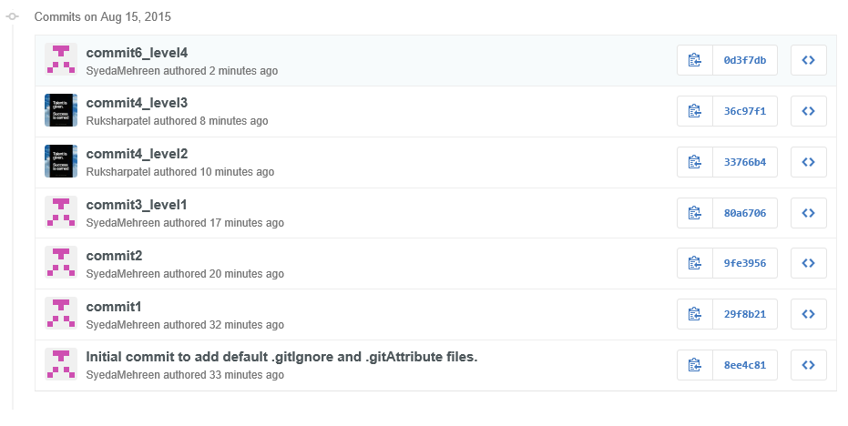

# Game Overview

*This is an arcade game in which the player has to help Superman in regaining his strength and fight the evil. The player will get five lives to go, and has to hit the maximum score. The player should pick the Superman logo to gain energy and should avoid hitting the kryptonites coming from the front. Each time the player collides with kryptonite will lose one life and for each ‘S’ logo the player will get ten points.*

# Game Play Mechanics

*The game is about the player controlling the Superman and save him from the front coming kryptonites and pick as many ‘S’ logos as possible.*

# Controls

*The only control that could be used in this game is the mouse. The user can move the Superman with the help of the mouse up and down in some level and right and left in others, while final level will engage the player to move Superman in any direction.*

# Saving and Loading

*No such feature as saving and loading has been added so far, but could be implemented in the upcoming versions.*

# Interface Sketch

*The game interface will give the player instruction at the beginning and then the user can start the game and play.*

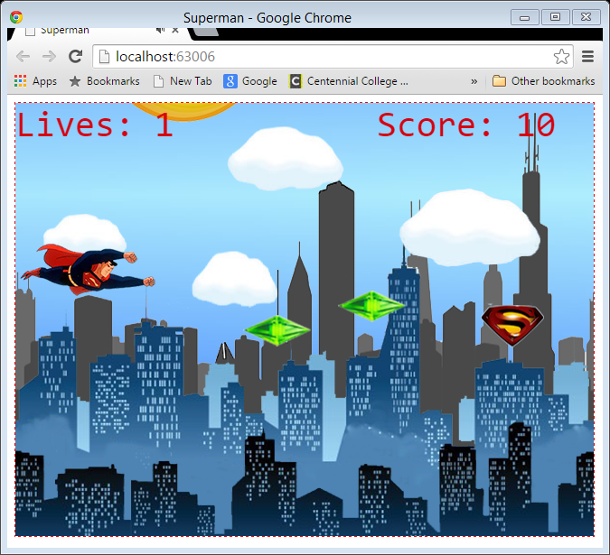

# Menu and Screen Descriptions

*The game have a menu which gives the user a little description about the game before starting it. And the end screen will show the user*his score and the high score.

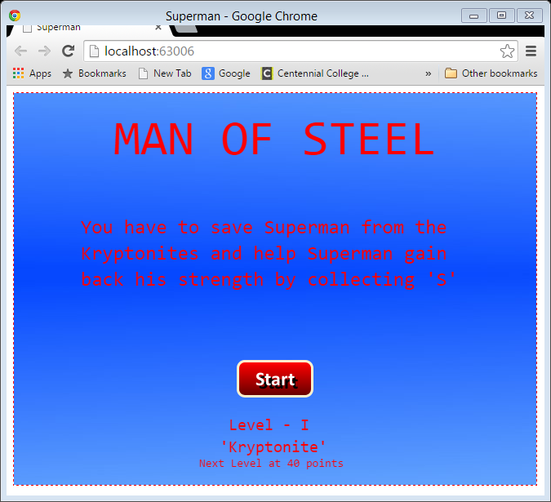

# Game World

*The game is on imaginary environment in which famous comic character Superman is flying and he has to save people and fight evil.*

# Game Progression

*The game progresses as the user keeps on saving the Superman and will end if the player gets out of lives.*

# Characters

*This game is based on a very famous character Superman. He is very popular among kids and youngsters.*

# Enemies

*The player has to tackle the person that is evil, his name is ‘Lex Luthor’. He is one of the business tycoons of the city of the metropolis.*

# Scripts

*Creation of this game was done in JavaScript.*

# Scoring

*The player can score infinite, as the player picks up the power or save lives of people each time he will be awarded ten points for that.*

# Cheat Codes

*No cheat codes are applicable for this game so far as the difficulty level is not much. But could be considered in the forthcoming versions.*

# Design Notes

*The designing of the game is kept simple to make it more user friendly. And the images used are from the various external sources.*

# Future Features

*In future the new features could be introduces like 3D characters, virtual weapons, sound effects, graphical rendering, etc.*

# Sound Index

*The game has only three sounds*

* *kryptonite.mp3 – for the falling kryptonite*
* *laser.mp3 – for the laser shot hit*
* *powerup.mp3 – when Superman will gain power*
* *superman.mp3 – this will be played during the gameplay*

# Art / Multimedia Index

*The development of game has many images*

* buildings1.png



* buildings2.png



* buildings3.png



* cloud_1.png



* cloud_2.png



* cloud_3.png



* cloud_4.png



* cloud_5.png



* dat-to-night.png



* kryptonite.png



* laser.png



* lex.png

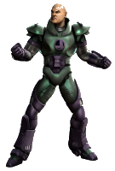

* missile.png



* people1.png



* people2.png



* people3.png



* people4.png



* people5.png



* playagain.png



* start.png



* sunmoon.png



* s-logo.png



* superman.png



# References

*The images used in this are taken from various sources*

* *Google images*
* *Hdwallpaers*
* *Superbwallpaers*
* *Wallpapersguy*

*The buttons used in this are taken from website*

* *dabuttonfactory*